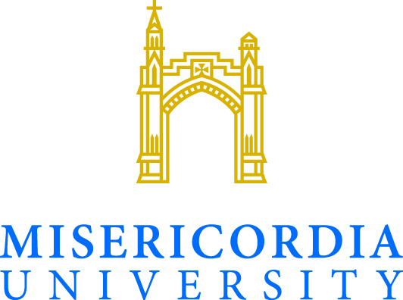

General Liability Release - Misericordia University
Event Date: Camp 2017 - Media
Event Time: June 25-28, 2017
I, the undersigned, do hereby consent and agree that Misericordia University, its employees, or students are not responsible for any incident or injury occurring during or in conjunction with Media Career Exploration Camp, including, but not limited to, event activities and transportation in University controlled vehicles.
I understand and will abide by all University rules and procedures; and will follow the regulations set forth by event organizers. The University reserves the right to exclude participants for willful disregard of laws and/or University policies.
I also understand that Misericordia University is not responsible for any expense or liability incurred as a result of my participation in this event.
I represent that I am at least 18 years of age, have read and understand the foregoing statement, and am competent to execute this agreement. Participants under the age of 18 must have parental or guardian authorization.
Name: Date:
Signature: ___________
Signature of parent or guardian (if under 18): _________________________
Event Organizer signature: ___________________________________

