FBI Fingerprints
This process takes time. Results can take weeks to be returned. Please plan accordingly.
Appointments to be fingerprinted are not required, but pre‐registration is required. Once registered, you may walk‐in during a location’s posted hours of operation, but scheduling an appointment may lead to lesser/no wait times.
Please pre-register at https://www.identogo.com/

Identogo (IDEMIA) uses service codes when identifying the authorized purpose for why an applicant is being fingerprinted. This ensures applicants are processed for the correct purpose and agency.

Below are the service codes available for Misericordia applicants applying under the DHS:
Service Code | Applicant Type
1KG6ZJ | DHS Volunteer
1KG756 | Employee >=14 Years Contact w/ Children

If you are experiencing difficulties, please follow the step-by-step instructions below (pay attention to the red arrows):

- https://www.identogo.com/ On Identogo’s homepage, click on ‘Get Fingerprinted’
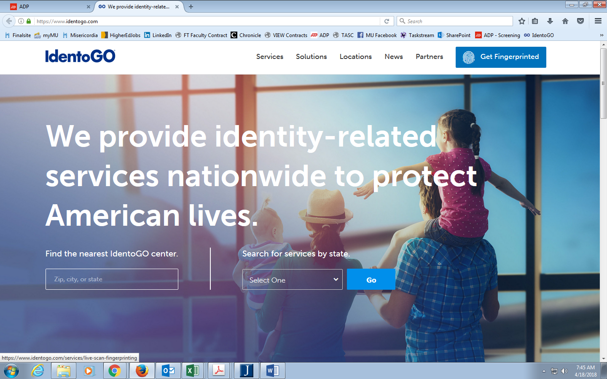

- Enter zip code 18612 in ‘Find an IdentoGo Center’
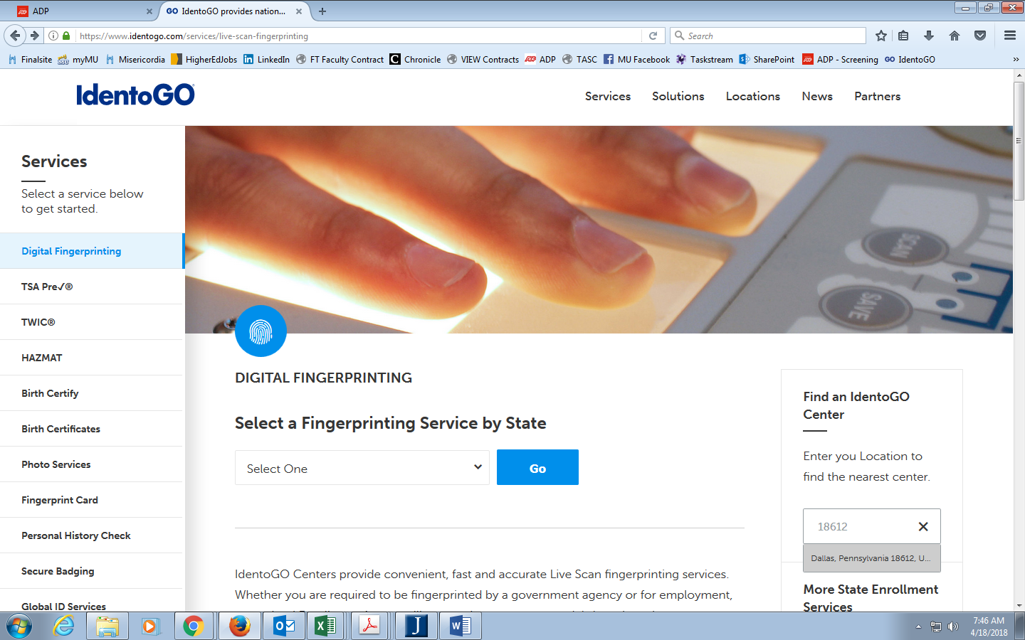

- Click on the first center that appears in the results
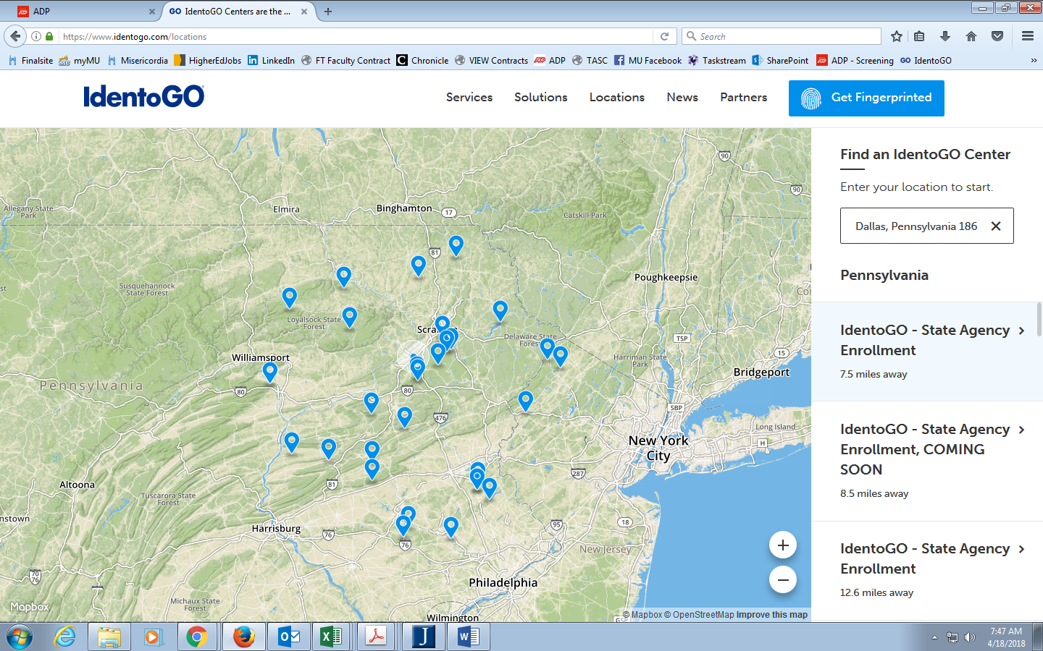

- Click ‘Schedule Appointment’

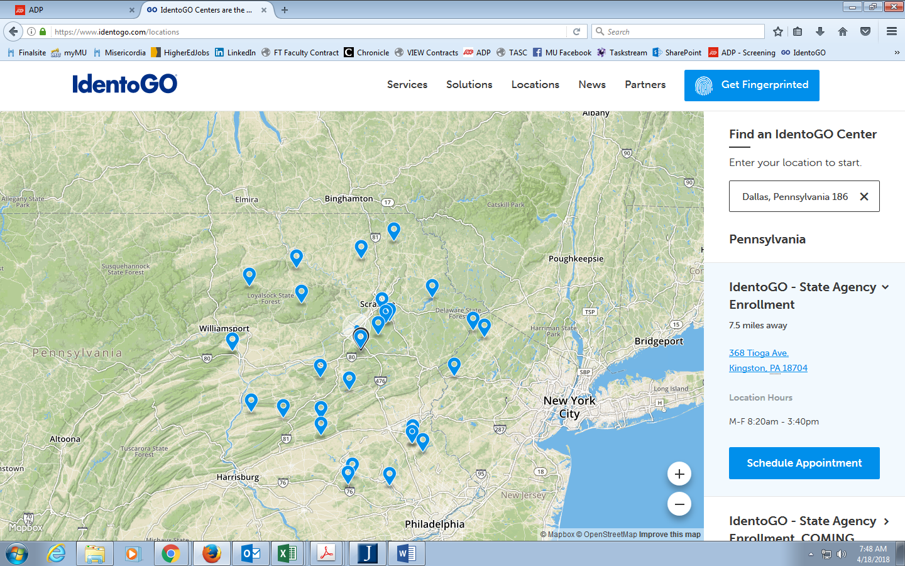

- Scroll to the middle of the page and click ‘Digital Fingerprinting’
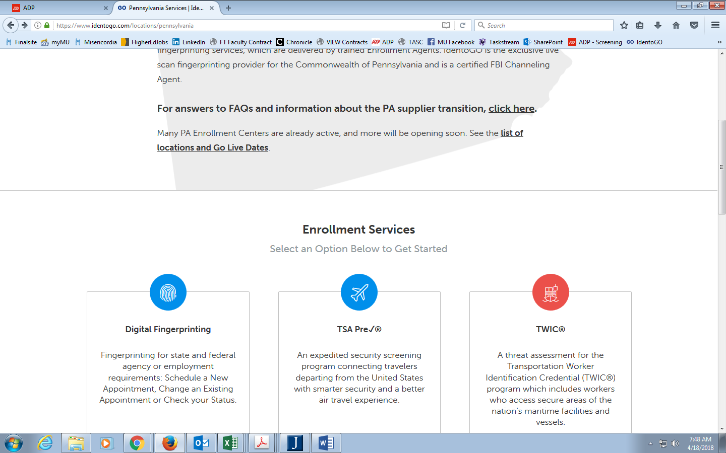

- Enter the appropriate Service Code and click ‘GO’
Copy code 1KG6ZJ (DHS Volunteer) if you will be an unpaid volunteer on campus
Copy code 1KG756 (Employee >=14 years contact w/ children) if you will be a paid employee

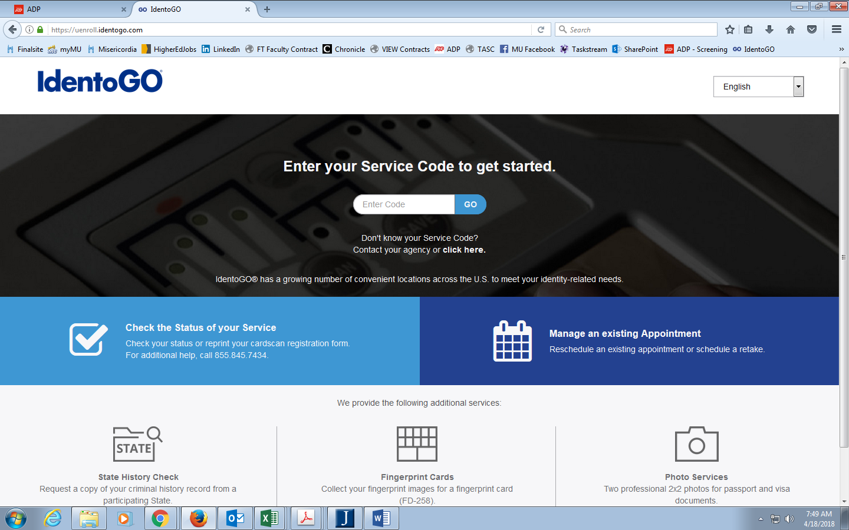

- Click on ‘Schedule or Manage Appointment’
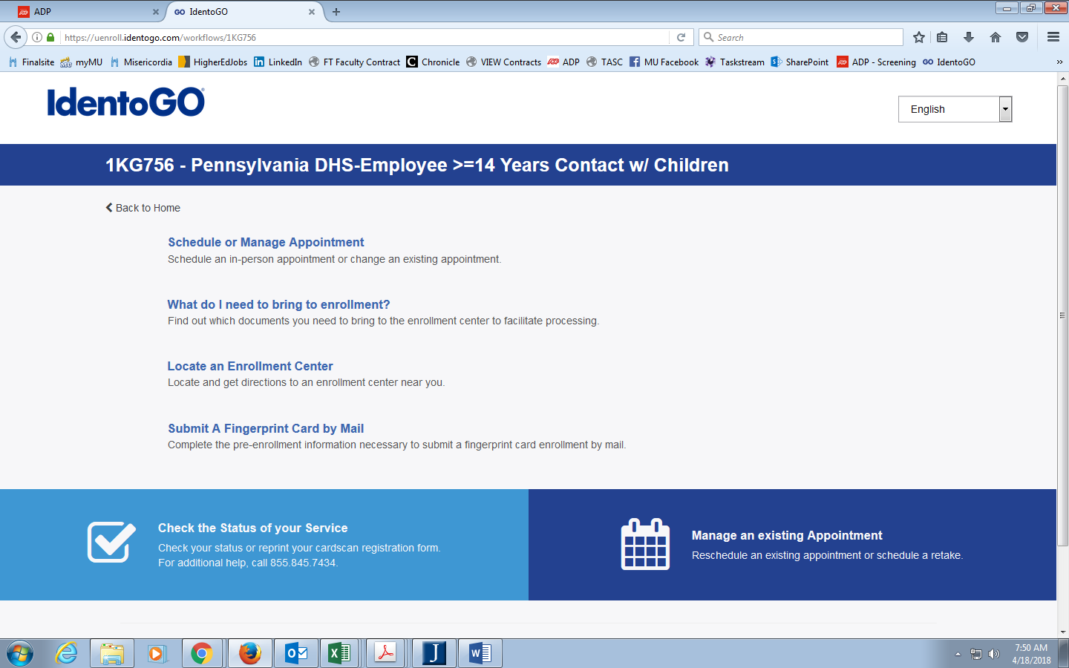

- Complete following pages
Following this page will be a series of pages you will need to complete.
*Employer should be entered as: Misericordia University 301 Lake St Dallas, PA 18612.

- Arrive for appointment with required documents.

- Official Results
Your official results will be mailed to your home address within the following few weeks.
They will arrive on a blue tinted, heavier stock paper (see example below).

Bring your Original Fingerprint results to Human Resources (copies will not be accepted).
You can submit your receipt at the time you hand in your official results for reimbursement.

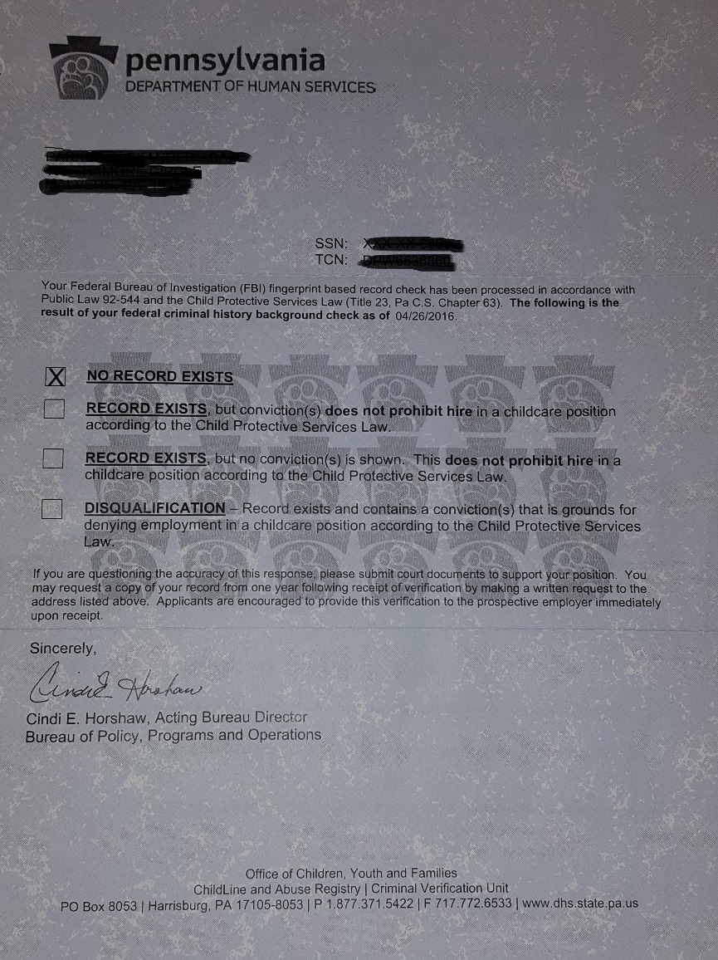

The following website will assist you in finding an IdentoGO site location: www.identogo.com/locations
For additional information contact Indentogo (IDEMIA) at 844-321-2101 or visit their website www.identogo.com.

