PA State Police Check – Retrieving Results:
Screen 1: Enter info – the control number will be in the email you received.
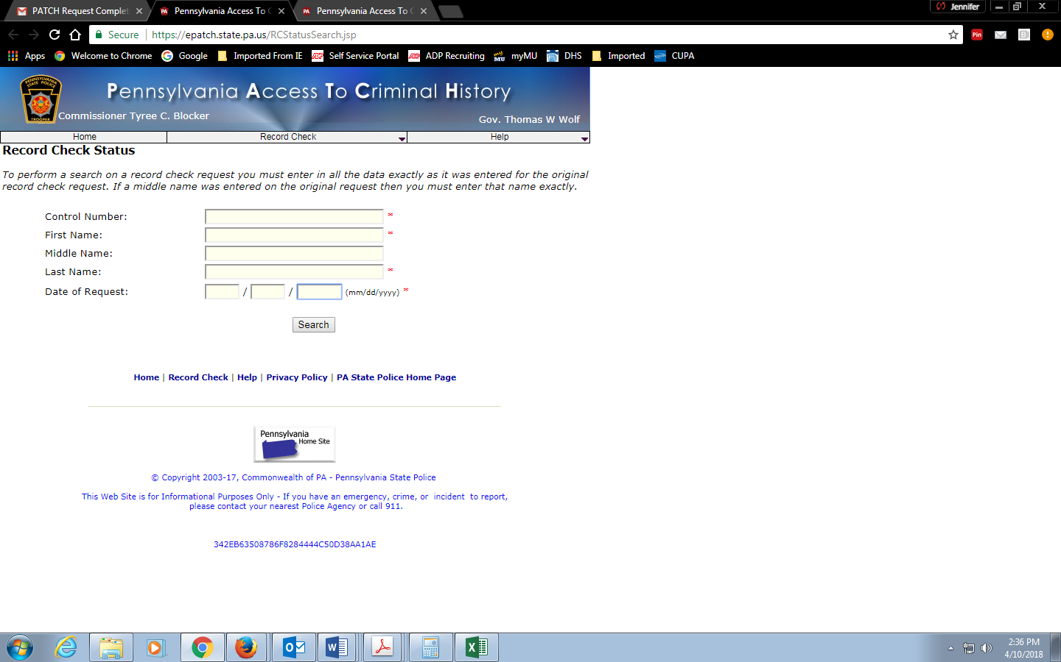

Screen 2: Click on the highlighted ‘Control Number’ (see below red arrow)
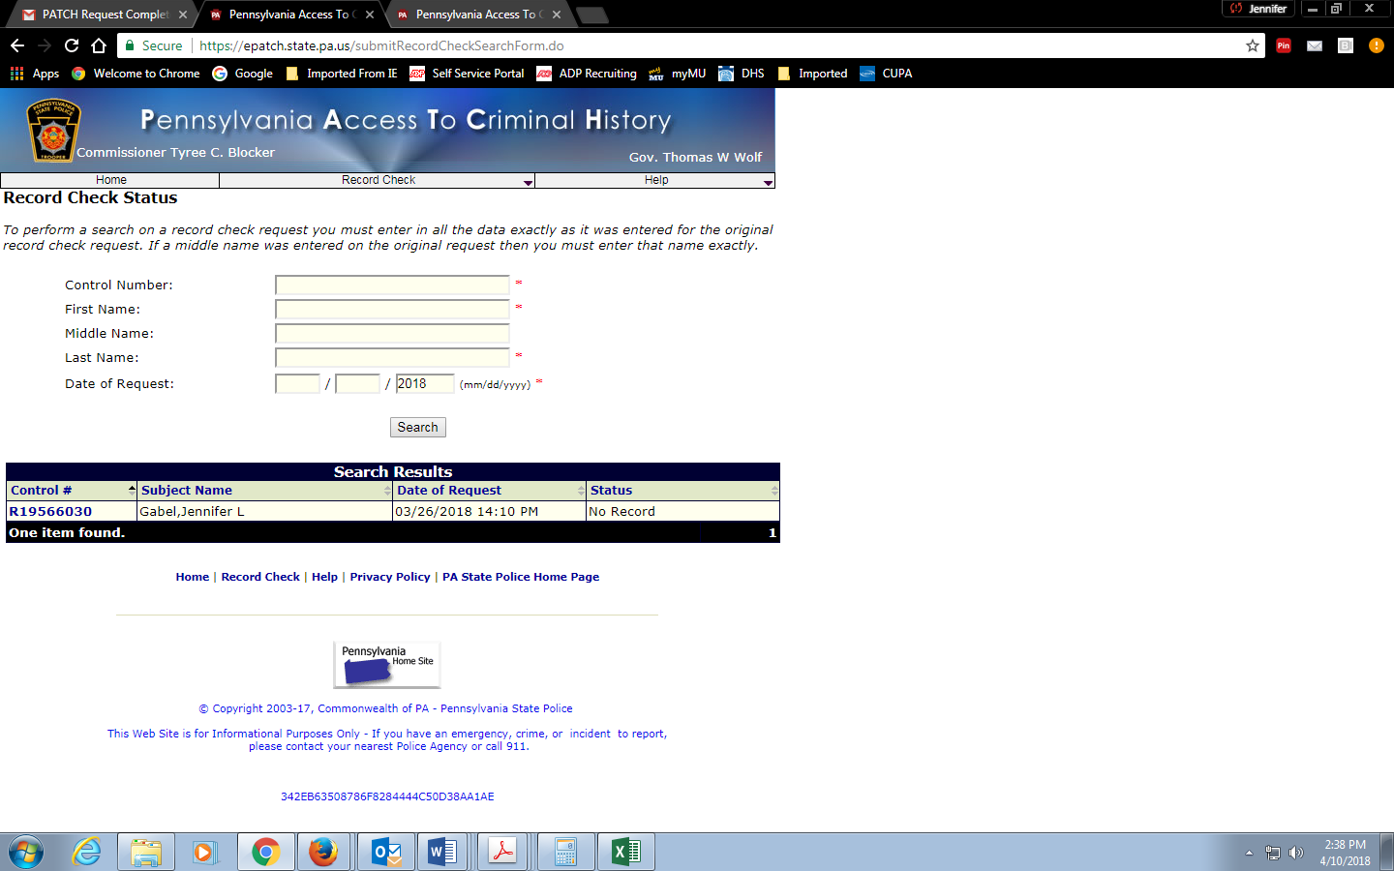
Screen 3: Click ‘Certification Form’
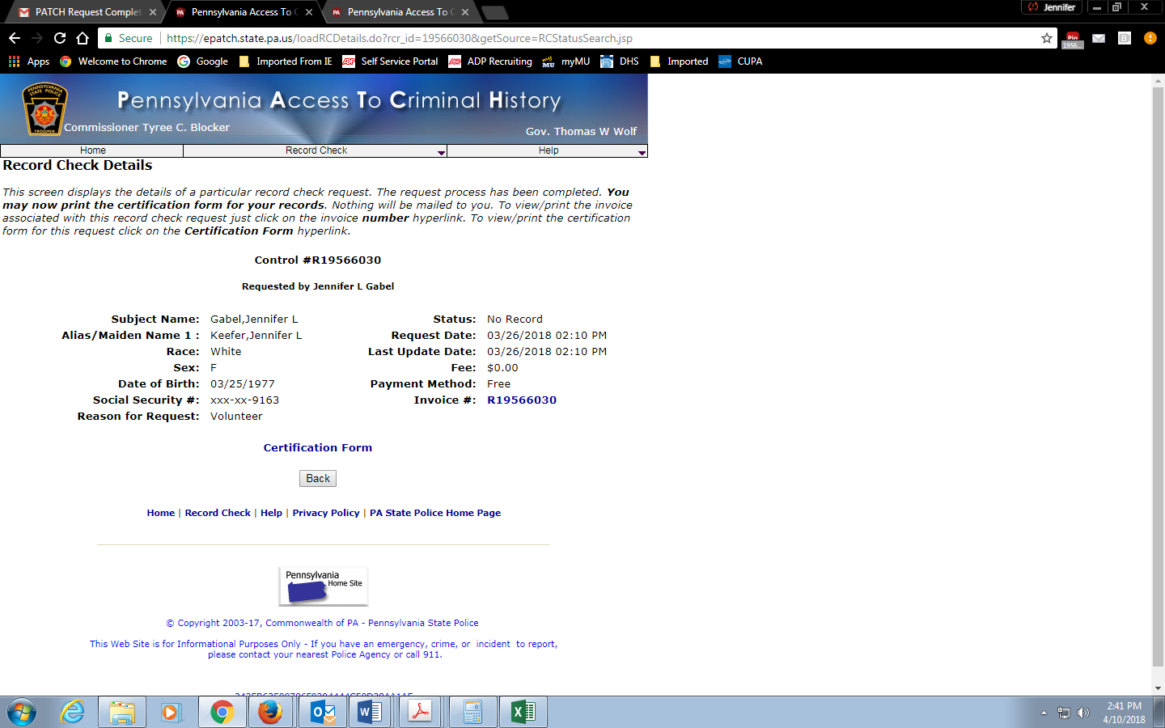

The form will download to the bottom of your screen. Open the form, SAVE AS a PDF and email to hr@misericordia.edu

